Impington & Witchford Adult Learning

New Learners - How to Register & Book Online

If you already go to Impington Sports Centre or have used it in the past, you may already be on their system. Please contact the Adult Learning Office on 01223 200411 or by email (adultlearning@living.tmet.org.uk) if you are unsure if you have a membership account or not.

If you do not have an account, you will first need to register and create a membership account via the Impington Sports Centre website to book courses online at Impington Village College & Witchford Village College.

If you are using a mobile phone or iPad, you may not be able to view all the options. You will need to switch your device to view full website and try again.

Step 1
Go to the Impington Sports Centre website:

https://www.impington.cambs.sch.uk/impingtonsportscentre
Click on Members Area

You will now see the Account Login screen. Click on REGISTER where it says Register for Online Booking and Courses Parent Portal.

Click here

Step 2
You will now see the Registration screen. Complete all the sections. Where it says My Home Leisure Centre, leave as Impington Sports Centre. This also applies for learners wanting to book courses at Witchford Village College.

Leave as Impington Sports Centre (including learners who want to book courses at Witchford).
Your registration will be confirmed by email and you will be sent a link in order to access your online account. The link is valid for 24 hours.

Step 3
You will now receive an email like the one below from noreply@legendware.co.uk asking you to log in. Click on the link within the email. This will take you back to the website, where you need to create a password.

Your confirmation
Dear Joe,
Thanks for registering
To log in to the online memberzone simply click here. This link is valid for 24 hours, after which you need to reset you password on the website.
Once you have created a password, you will be directed to the Welcome Screen.

Step 4
You will now be able to book onto a course. Under Bookings, you will see Search for Sports Courses.
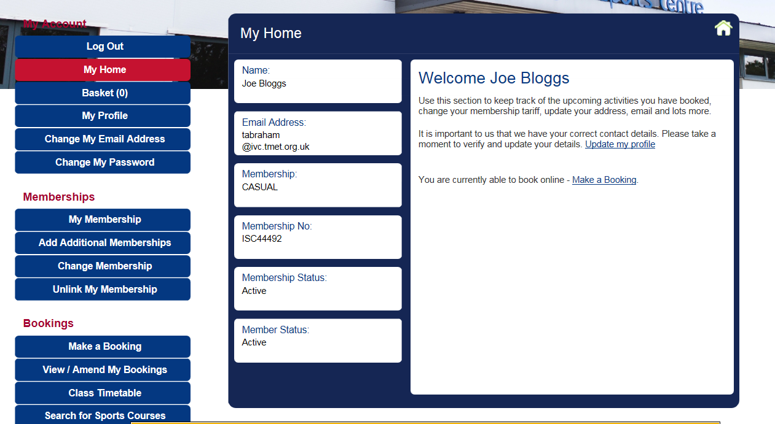
Click on
Search for Sports Courses

Enter the name of the course you want to book in the course search. Example – Strictly Dance Workout
Click Search
You will then see the results of your search. Click on your chosen course.

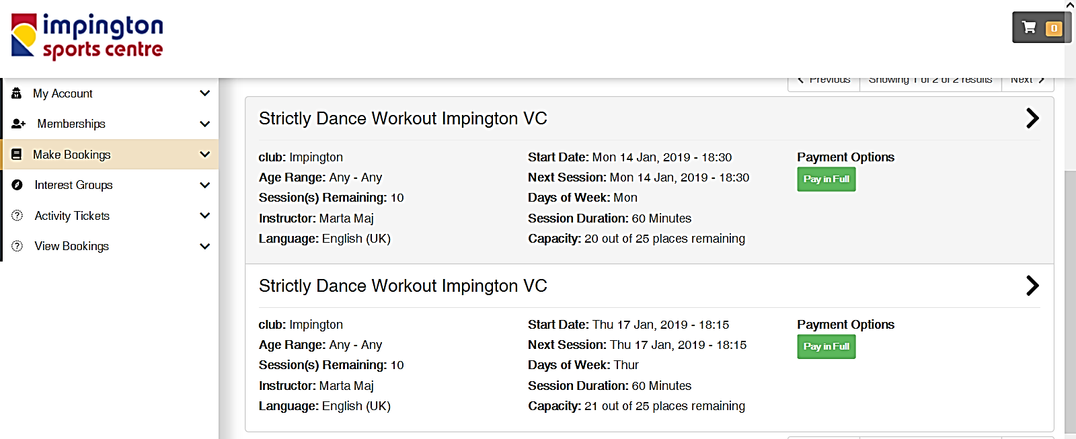

You will then be asked to pay for your course in full. Once you have paid online, you will receive an email confirming payment.

Please note, this is not a confirmation of the course running.

Adult Learning will notify you direct by email if the course is running or cancelled.

