Careers Education, information advice and guidance Strategy

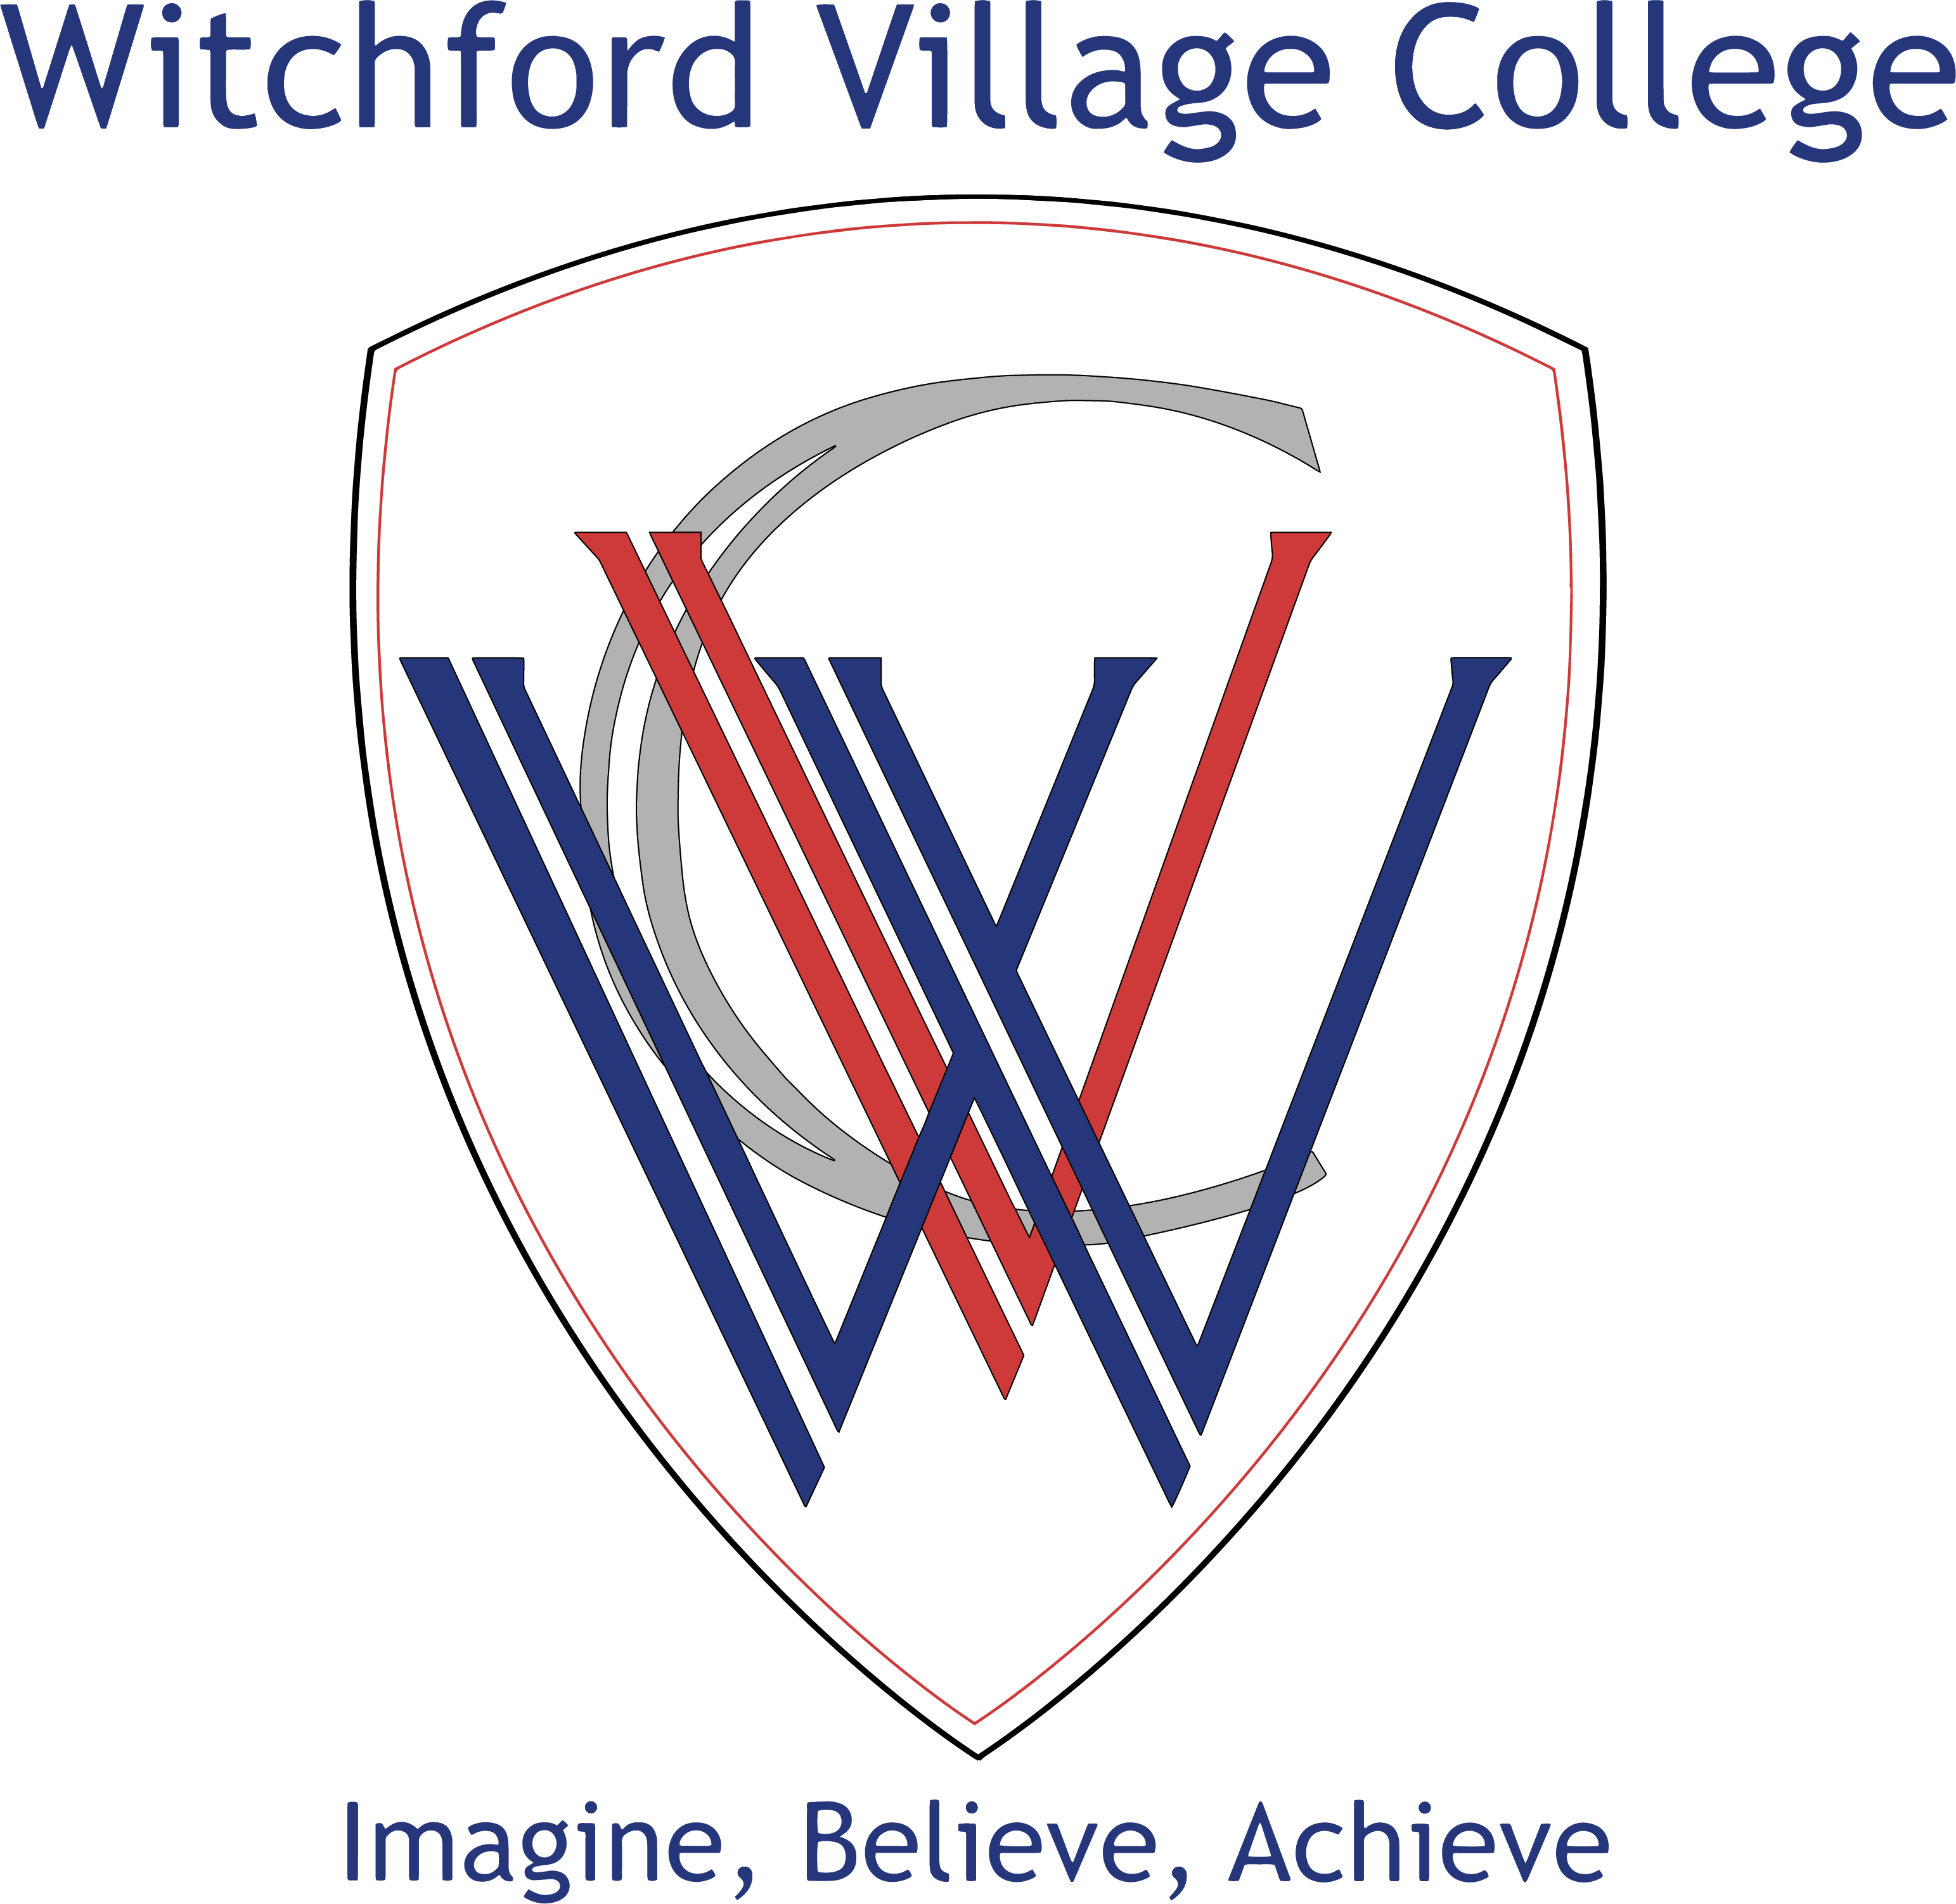

Current Status: | Up to Date | Last Reviewed: | Sept 2019
Responsibility for Review: | Head of Careers | Next Review: | Sept 2022
Approval: | LGB | Date: | Oct 2019

Careers Education, Information, Advice and Guidance Strategy
Introduction and Vision
Our vision for CEIAG at Witchford Village College is:

To provide a comprehensive and progressive programme that provides effective careers information, advice and guidance for all students. Student’s aspirations must be raised and focus must be given to widening their perspective on the world of work and enabling them to make informed, realistic decisions at all key transition points throughout their life. We are a fully inclusive school and believe that support and encouragement is a necessity for all students to ensure that they make the best decisions for their future but also build resilience and a deeper understanding for the ever-changing world that we live in.

This strategy sets out a clear plan on how we intend to work towards meeting this vision and includes the statutory responsibilities for securing access to independent and impartial careers guidance for all pupils in year 7-11. The Department for Education’s statutory guidance: “Careers Guidance and Access for Education and training providers” – published in 2014 and updated in 2018 sets out how careers guidance must be secured under the new duty to include information on all 16-18 education or training providers, including apprenticeships. The Careers Strategy is to be read in conjunction with our Careers Policy that can be found on the Policy page of our website under Careers, Information and Guidance.

Our Objectives
- To ensure that Witchford Village College has a concise plan of engagement in CEIAG for all students so ensuring that they work hard and strive to be the best they can be
- To meet the eight Gatsby benchmarks for good career guidance as recommended by the Department of Education Careers Strategy 2018
- To gain the ‘Quality in Careers Standard’ accreditation, the nationally recognised award for CEIAG in English Secondary Schools.
- To provide effective and impartial information, advice and guidance so preparing students for life in the wider world, making them aware of roles and responsibilities
- To raise aspirations by ensuring all students have knowledge of routes into further education, higher education and apprenticeships (of all levels)
- To ensure every student is offered careers guidance to meet their needs at the different stages through their school journey. This will reflect WVC’s equality and diversity policy to ensure that every student is treated fairly
- To engage with local employers and training providers in order to provide multiple learning opportunities about the world of work and skills required. Both academic and vocational routes are explored and are available to students regardless of career choices
- To make available Labour Market Information to ensure students (and parents) are aware of local and national opportunities as well as trends to ensure they are informed to make the best decisions.
- To ensure all staff at WVC have an awareness of linking curriculum learning to careers and are able to demonstrate the relevance of subjects to students when considering a future career. Particularly relevant is that STEM subject staff should highlight the increasing need for STEM subjects to access a wide range of future career paths, making sure the information does not stereotype in any way
- To ensure all students are aware that the attainment of English and Maths GCSEs are crucial elements of any future study programme they may undertake and an expectation from all employers
- To approve work experience opportunities for Year 10 students on an individual basis as deemed appropriate to the student, for a maximum of five days and at a juncture in the students school year that will not cause disruption to their learning
- To continuously strive to improve NEET figures by providing an effective careers programme
- To actively track the progress of Pupil Premium and students from disadvantaged backgrounds to ensure that they access all of the careers information, advice and guidance to enable them to make the relevant decisions to their career goals
- To tailor information, advice and guidance as necessary to meet the needs of any SEN students and offer appropriate alternatives as deemed necessary.

Our Offer
Our careers strategy enables students to be:
- engaged in understanding the world of work and be motivated to pursue a job or career
- aware of options in the labour market, locally, nationally and internationally
- aware of their current strengths and interests and what is needed to support their goals and aspirations
- aligned to labour market opportunities and able to acquire skills and behaviours necessary to attain their desired employment
- motivated to engage in all opportunities that are offered to them to ensure their success
- develop confidence and resilience to engage proactively in the world of work
- able to see the importance of gaining the best qualifications they can to ensure they have a wider choice of career options

We have a planned approach to careers information, advice and guidance in each year as follows with each activity mapped against the Gatsby Benchmarks, as listed below. To ascertain Benchmark 1 all of the other benchmarks have to be in place in an embedded programme.

- A Stable Careers Programme
- Learning from Career and Labour Market Information
- Addressing the Needs of Each Pupil
- Linking Curriculum Learning to Careers
- Encounters with Employers and Employees
- Experiences of Workplaces
- Encounters with Further and Higher Education
- Personal Guidance
Year Group | What we offer | Benchmarks Met
Year 7 | - Careers education units in PSHE to cover strengths and weaknesses, careers and jobs, skills and qualities for work.  - Take part in Activote, which gives a baseline of students understanding of careers.  - Careers Enterprise Activity – Ducks – engaging with employers and providers  - Attendance at The Big Bang – STEM Event University of Hertfordshire | 2, 4  2, 3  5, 6  5, 7
Year 8 | - Careers education units in PSHE to include labour market information, entrepreneurship and enterprise, making choices, the importance of skills in the work place  - Guided Pathways Day – an insight into careers and the opportunity to take subjects tasters as preparation for the options process  - Challenge Day with EDT – event to enhance students awareness of STEM subjects  - Engaging students in Guidance Meetings to ensure option choices are viable | 2, 4  4, 2, 5, 3  2, 4, 5  3, 8
Year 9 | - Students to engage in Individual Learning Plan Process – to understand setting SMART targets and steps to progress and LMI – guidance meetings offered  - PSHE sessions to be delivered by Future First in respect of world of work and students to engage with Alumni  - Opportunity for students to attend KS4 Pathways and Progress evening to encourage career plans  - Eyes on the Prize event at Anglia Ruskin – engagement with HE provider to raise aspirations  - Students to take part in Creating the Future – Arts and Cultural days – focusing on employment sector | 2, 3, 8  4, 5, 6  3, 7  7  5, 6
Year 10 | - Mock interview skills day – to ensure students understand soft skills and the processes behind which employers want to engage and recruit  - Opportunity for students to attend KS4 Pathways and Progress evening to encourage career planning  - Students introduced to the Post 16 application process through focused workshops and guidance meetings  - STEM engagement opportunities linked to careers in engineering, construction and science  - University visits as arranged  - Taster Days to Further Education Colleges  - Work Experience offered to students, provision of information and advice for holiday based placements  - Opportunities for students to attend Post 16 Open Evenings (Summer term)  - Engagement of Enterprise Advisor to encourage local employers to talk to students about opportunities, either in school or at their work place | 4, 5, 6  3, 7  2, 7, 8  5  7  7  6  7  2, 5, 6
Year 11 | - Assemblies from outside providers with a focus on pathways at Post 16 and LMI  - Dedicated drop down day for focused time by outside speaker on Exam Busters and Mind Mapping  - Generating and exploring career ideas based on their own interests, skills and aspirations  - Helping students prepare for transitions post-16 – ie. Additional visits to post 16 centres, meetings with post 16 transition co-ordinators  - Targeted 1 to 1 Guidance Meetings  - All students to attend East Cambs Careers Fair  - Dedicated day, Tutor and additional drop in (lunch and after school) sessions to support students with writing personal statements and completing applications  - Use of Labour Market Information to demonstrate the changing job market, up and coming trends and links to current subject choices  - Workshops for students on university choice to inform Post 16 choice  - Opportunities for students to attend KS4 Pathways and Progress Evening  - Distribution of Post 16 Prospectus  - Pre-Apprenticeship workshops to support those students wishing to follow this pathway | 2, 5, 7  3  3, 4, 5  8, 3  8  5, 6, 7  3  2, 4  7  3, 5, 7  7  5, 6

Employer Engagement
We aim as a school to ensure that all students have a least one meaningful encounter with an employer per year, but from experience, this has always been exceeded. Working with employers enables the school to understand the challenges faced by organisation’s employing young people. This in turn can inform our strategy so as to ensure that we close the divide between the understanding of what employers need and the information and advice that we give to students. We understand the importance of these links and will work pro-actively to ensure they are strengthened within the community. Working with employers also enables the school to provide impartial careers guidance across a range of pathways such as university, apprenticeships and other vocational pathways and establishes routes to employment that may not always be obvious. In addition we have the expertise of an Enterprise Advisor who is a business volunteer and able to engage with the business community to align experiences offered by employers to our needs at WVC. This ensures that employer engagement and employability skills are increased and in line with employer expectations through stronger relationships. The Skills Service also offer a brokerage service through a SLA which allows further employer engagement and the “buying in” of enterprise experience days.

Alumni
In 2018 with the support of Future First, WVC set up an alumni network to recruit former students with the aim of growing our employer network. To date we have approximately 100 members and the number continues to grow. Our alumni community gives us access to role models from a wide range of backgrounds, careers and experience. We continue to promote this activity through the local magazine Fenscene, on our school website and twitter feed. Our Alumni have engaged students in workshops such as the World of Work during PSHE lessons and we continue to encourage regular contact with them for to support and assist at school events.

Staffing
Through their own roles as tutors and subject teachers all staff contribute to CEIAG. To ensure that careers is embedded into the curriculum wherever possible it is an aim of this strategy to continuously review and revise the information cascaded to staff. To enable staff to fully support the careers programme availability must be made of up to date resources and to ensure that any CPD requirements are met. This will enable the staff to become confident in helping to raise aspirations, define career goals and support students during their college application process as well as other key transition points in their school journey.
Resources and Information
Students can access relevant resources and information through various mediums. Information sent to the school via outside agencies is forwarded on to students via the internal email system if deemed appropriate. Information is sent to parents using Edulink or the school In Touch emailing system. Information is delivered via a powerpoint presentation known as the student bulletin during form time once per week and the school website is kept up to date with all relevant resources and information for students to access at home or during the school day. The Resources drive of the schools IT provision allows documents to be added that are relevant and would be of particular use during the sixth form college application process. Parents have access to the Edulink and also the schools website, where there is a dedicated section for Careers. The school promote the use of the website Youthoria – which is the Cambs County Council website for young people – and also the National Careers website. Employers and stakeholders are also able to view the website and additional information, as long as it is pertinent to the careers at school can also be added on request.

Evaluation of the Careers Programme
It is important that we measure the impact of our strategy through student, employer and parent feedback. We access this information in several ways by obtaining verbal and written feedback or accessing the results of a dedicated on-line survey. The results and responses then inform how we reflect on and enhance the programme for future use. We also track the destinations of our students Post 16 and Post 18 by information received from Post 16/18 providers and also the County Council Destination Data. We use the Careers and Enterprise Company’s Compass Tool to self-assess our strategy against the Gatsby Benchmarks at regular intervals through the academic year. These results are then shared with our Enterprise Co-ordinator to inform progress travelled.

Roles and Responsibilities
Careers guidance is the responsibility of all relevant staff at Witchford Village College.
Listed below are key members of staff who have responsibility for CEIAG.

Name | Title | Main responsibilities
Zoe Tregear | Assistant Principal for Curriculum | To oversee all careers engagement and ensure that SLT are fully informed of all opportunities and experiences.
Juliet Martin | Careers Leader | Developing CEIAG strategy, ensuring careers programme offers all students opportunities and enrichment. This will then guarantee that when they leave WVC they have had a comprehensive careers experience which, ensuring that when they enter the world of work they are fully prepared.
Juliet Martin | Guidance Adviser | To offer 1:1 interviews to all students at a time within their school life when it is the most pertinent to their development.
Sue Taylor | SENCo | Co-ordinating EHCP paperwork and advising Guidance Advisor of students who require interviews. Ensuring that all SEN students engage fully with the CEIAG programme.
Alvina Morey | Enterprise Co-ordinator | To support employer engagement and liaise with Careers Leader to ensure that all opportunities are available and offered to WVC from the local area and beyond.
Alan Todd | Enterprise Adviser | Liaising with Careers Leader to ensure that the Business Community provide experiences for students of the world of work.
Anne Hall | Link Governor | To ensure that WVC fulfils its statutory requirements in respect of CEIAG. Offer support as required.
James Pinkney | PSHE Lead | Responsibility for organising PSHE programme. To ensure that CEIAG is integral to the process and that relevant time is made available to accommodate the logistics.
Philippa Spencer | Pupil Premium Champion | Responsibility to ensure that all pupil premium students engage in the CEIAG programme, by attending organising trips and being offered 1:1 guidance.

