Descriptive Writing – Year 8 Knowledge organiser
Dialogue/speech  Inner dialogue: can be explained roughly as an inner conversation (usually with the self)  Outer dialogue: is a conversation between two different people.  Direct speech is usually placed inside quotation marks and accompanied by a reporting verb, signal phrase, or quotative frame. She says, "What time will you be home?"  Indirect: a speaker's words reported in subordinate clauses governed by a reporting verb, with the required changes of person and tense (e.g. he said that he would go, based on I will go ). |  | Imagery  Visual – sense of sight, imagine a picture  Auditory – sounds that are happening.  Tactile – sense of touch.  Kinaesthetic – movement or action of object/people. |  | Useful structure for writing  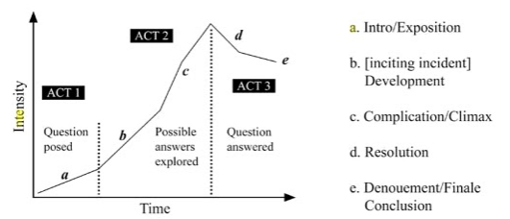 |  | Sentence openings  3 word sentence  Rhetorical question  -Ed word  The more ….. the more  Sounds  Pairs of adjectives  -Ing words.  Inside/outside focus  Semi colon  Similes  Syntax sentences that mirror emotion and action  Subordinate clauses  Fronted adverbials  Prepositional phrases  Subordinating conjunctions
Useful vocabulary for in class textual analysis
To sob | embers |  | Absent-mindedly |  | To rustle
To craft | clogged |  | thunderous |  | To stagger
peppered | To startle |  | exertion |  | To splodge
dome-like | ecstatic |  | crease |  | hollow
quilt | To be thrilled |  | gesture |  | To reverberate
scorching | To be wound (wind) up |  | shackles |  | To flutter
bulk | To be maddened |  | longhouse |  | motion
numerous | blaring |  | distorted |  | illumination
texture | densely |  | auto tune |  | melodies
slick | To ridicule |  | Armour plated |  | Brashly

