Charles Darwin’s, ‘Theory of Evolution by Natural Selection’  Darwin’s theory of evolution by natural selection challenged the idea that God made all the animals and plants that live on Earth.  - individuals with characteristics most suited to the environment are more likely to survive to breed successfully  - the characteristics that have enabled these individuals to survive are then passed on to the next generation. | The Iceni were a Brittonic tribe of eastern Britain during the Iron Age and early Roman era.  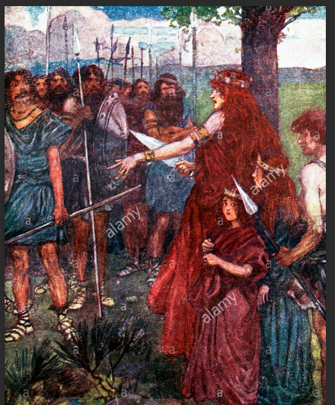
Slate roofed cottages are popular in Britain’s national parks where slate was mined from the 1800s.  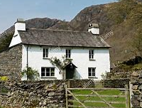 | Mother Nature is a common personification of nature that focuses on the life-giving and nurturing aspects of nature by embodying it, in the form of the mother.  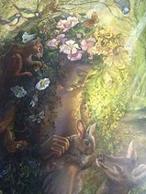
Hotel Negresco, Nice, France  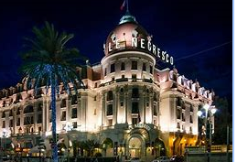 | Alcedo is a genus of birds in the kingfisher subfamily Alcedininae. Alcedo is the Latin for "kingfisher".  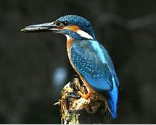
The Euro is a currency used in Europe: | The town of Nice in France  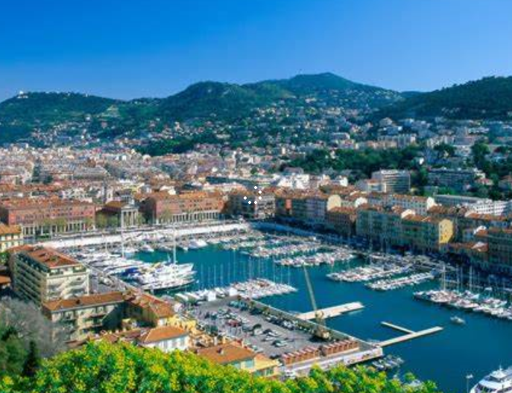
Ford Ka – a budget car popular in the early 2000s  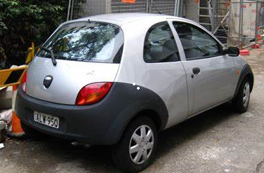 | The village of Èze in Provence-Alpes-Cote d'Azur, France.  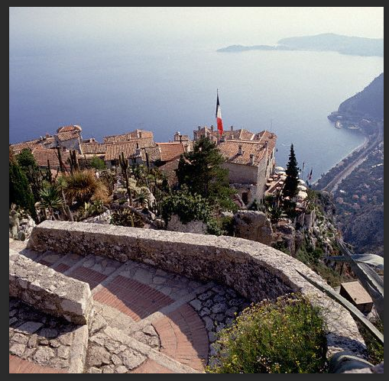
The A6 is one of the main historic north–south roads in England. It currently runs from Luton in Bedfordshire to Carlisle in Cumbria, although it formerly started at a junction with the A1 at Barnet.  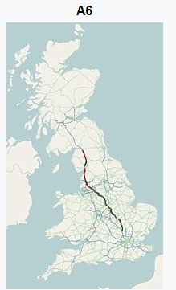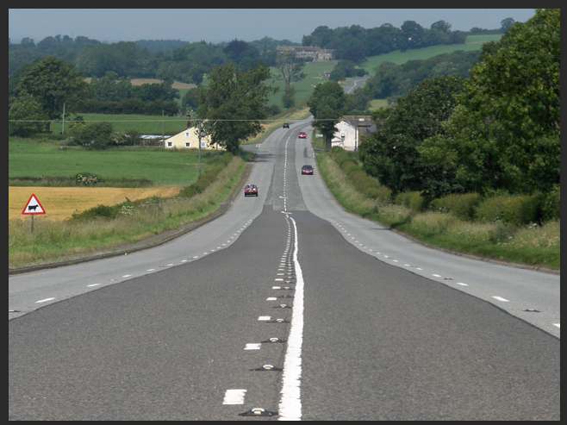 | The French Mediterranean and Cote D’Azur and French Riviera  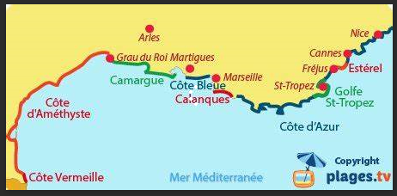  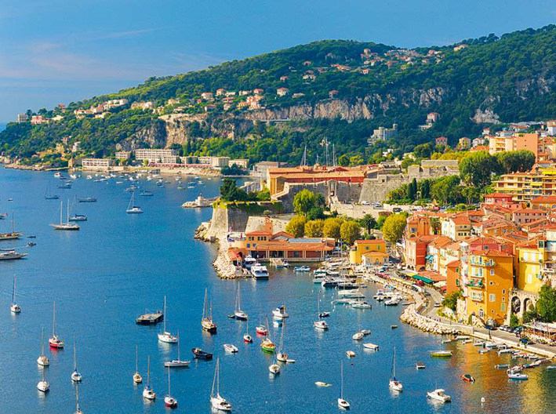
Michelin Star Restaurant: a guide to the best restaurants. Sponsored originally by Michelin Tyres which was published to advise drivers where they could stop for an excellent lunch. The best restaurants are awarded a Michelin star.  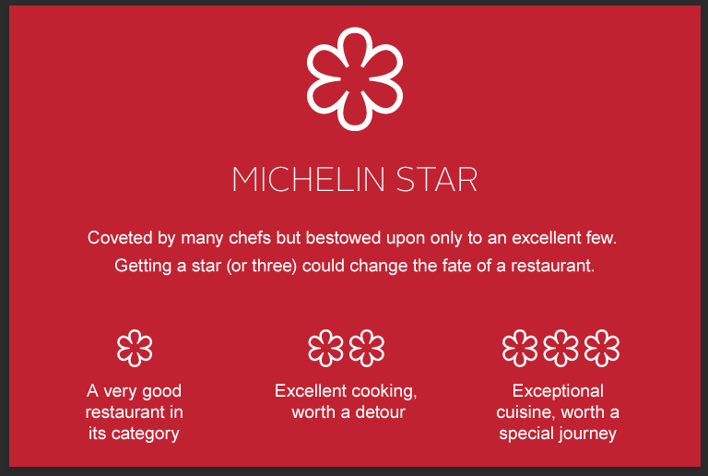 | The town of Cannes, France  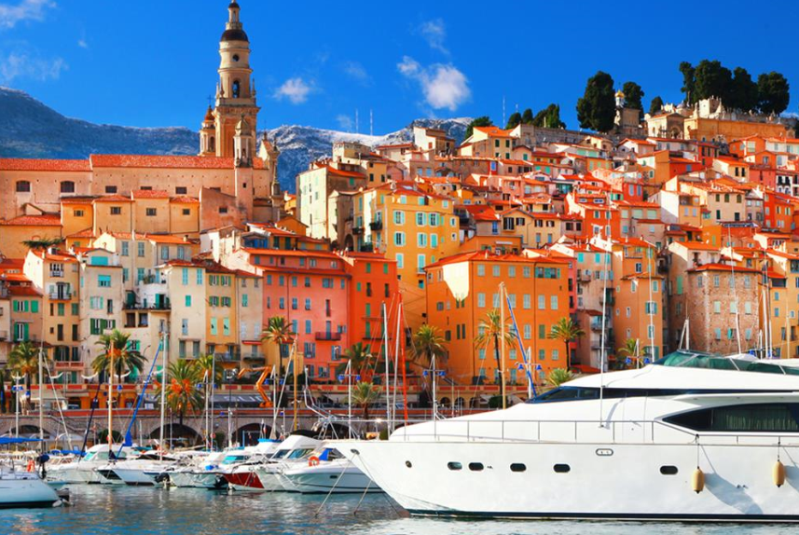
The Edale Village in the Peak District  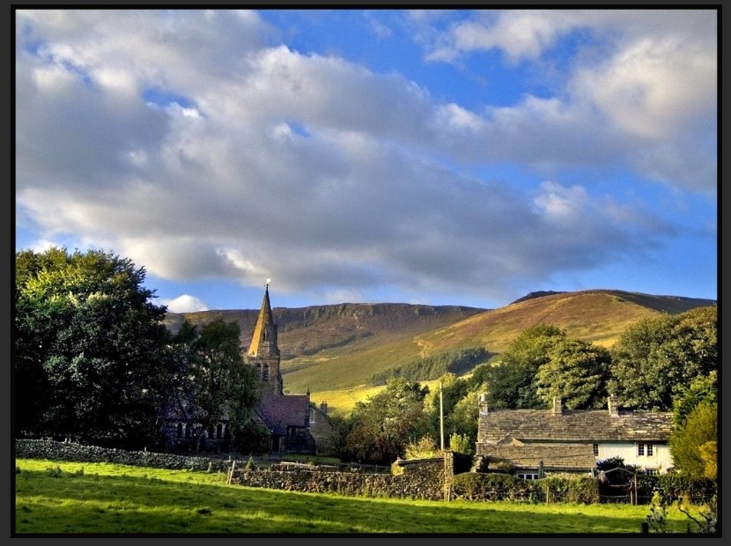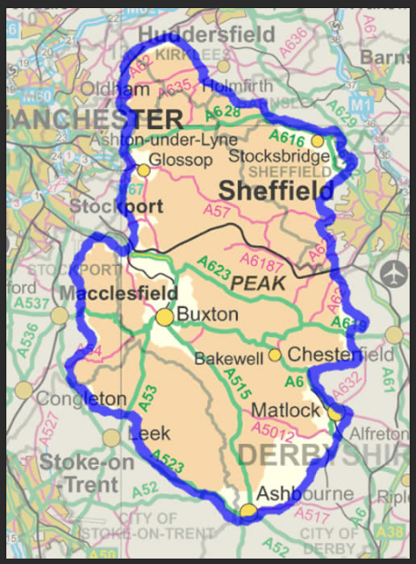 | The Galapagos islands  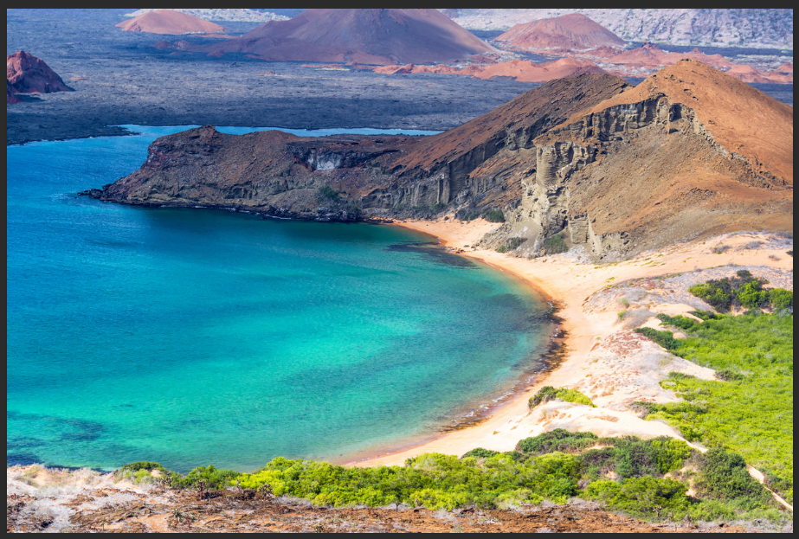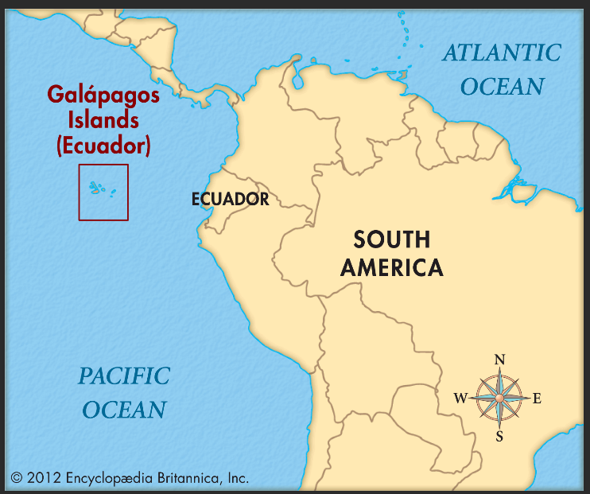
The Parthenon Marbles also known as the Elgin Marbles are a collection of Classical Greek marble sculptures made under the supervision of the architect and sculptor Phidias and his assistants. They were originally part of the temple of the Parthenon and other buildings on the Acropolis of Athens. 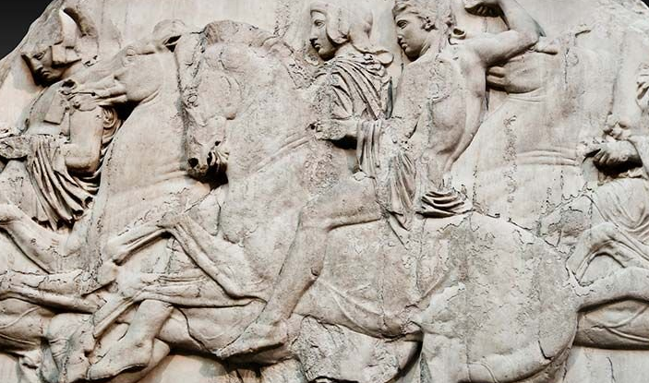 | The Rosetta Stone, found in 1799, inscribed with three versions of a decree issued at Memphis, Egypt, in 196 BC during the Ptolemaic dynasty on behalf of King Ptolemy V. The Rosetta Stone proved to be the key to deciphering Egyptian hieroglyphs, thereby opening a window into ancient Egyptian history. 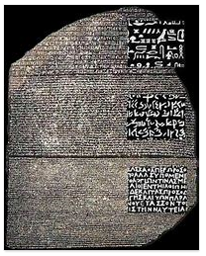
The Norman Conquest of England was the 11th-century invasion and occupation of England by an army of Norman, Breton, Flemish, and French soldiers led by the Duke of Normandy, later styled William the Conqueror. 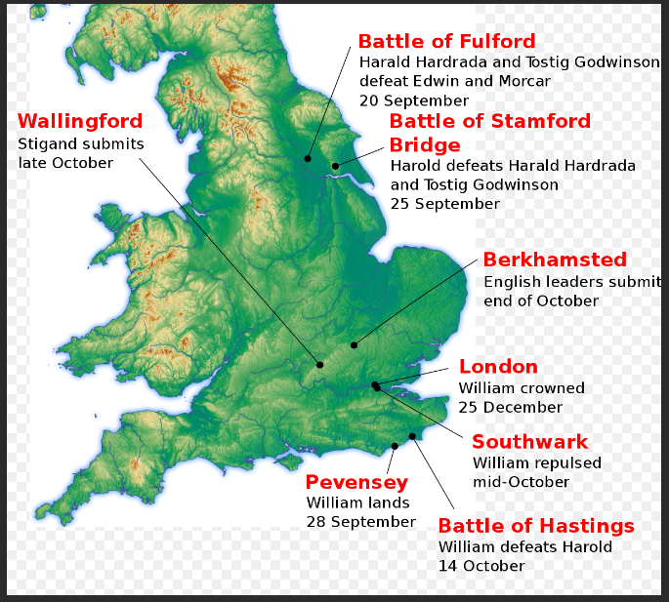 | Black Death: the great epidemic of a disease thought to be bubonic plague, which killed a large proportion of the population of Europe in the mid-14th century. It originated in central Asia and China and spread rapidly through Europe, carried by the fleas of black rats, reaching England in 1348 and killing between one third and one half of the population in a matter of months. 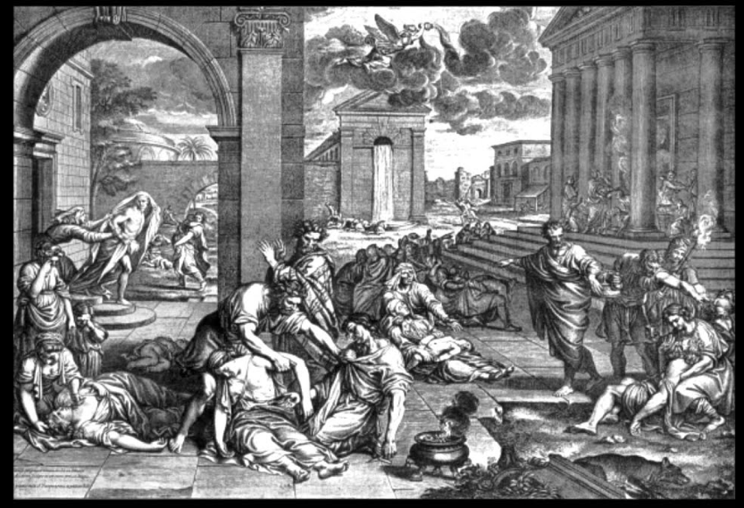
A World Heritage Site is a place that is listed by the United Nations Educational, Scientific and Cultural Organization (UNESCO) as of special cultural or physical significance.  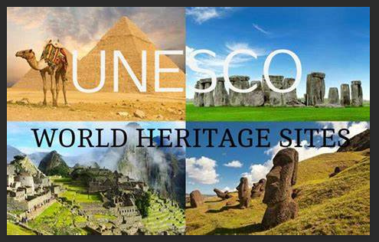 | The Crown Jewels of the United Kingdom, originally the Crown Jewels of England, are 140 royal ceremonial objects kept in the Tower of London, which include the regalia and vestments worn at their coronations by British kings and queens.  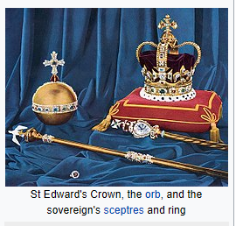
Beefeaters: The Yeomen Warders of Her Majesty's Royal Palace and Fortress the Tower of London, and Members of the Sovereign's Body Guard of the Yeoman Guard Extraordinary are ceremonial guardians of the Tower of London. In principle they are responsible for looking after any prisoners in the Tower and safeguarding the British crown jewels; they have also conducted guided tours since the Victorian era.  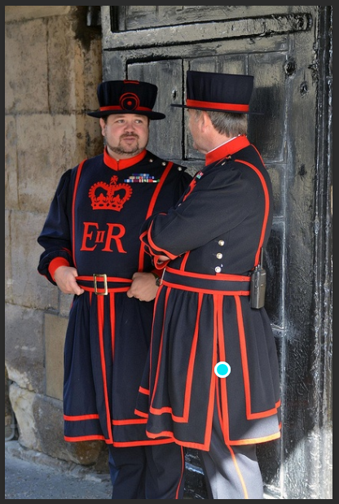 | Travelodge: a chain of budget hotels spread across the country
Covent Garden is a district in London, on the eastern fringes of the West End, between St Martin's Lane and Drury Lane. It is associated with the former fruit-and-vegetable market in the central square, now a popular shopping and tourist site, and with the Royal Opera House. 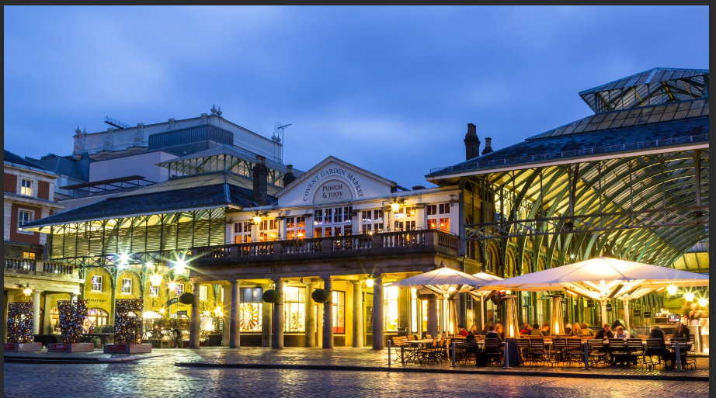 | Venice is a city in north eastern Italy and the capital of the Veneto region. It is situated on a group of 118 small islands that are separated by canals and linked by over 400 bridges.  