|  |  |
| --- | --- |
| **Educational Setting** | Witchford Village College |
| **Activity / Task** | COVID-19 Risk Management Assessment (Educational Settings) |
| **Completed by & Date** | 10 June 2020 – Dan Baxby, Fran Difranco |
| **Review Date** | 10th July 2020 or before if significant changes are needed |

**This risk assessment is written on the assumption that staff and students will self isolate, according to government instructions, if they or a household member have symptoms of Covid-19.**

|  |  |  |  |  |  |
| --- | --- | --- | --- | --- | --- |
| **What are the hazards?** | **Who might be harmed and *how*?** | **What are you doing already?** | **What further action is necessary?** | **Action by whom?** | **Action by when?** |
| Social Distancing in school | Transmission of virus between staff and students | * Students will be allocated to classes of no more than 10/12 and will remain in these classes each day. * A maximum of 25% of students in year 10 will attend each day * Classes will be allocated to a specific room in the College and will use this room each day, including entering and exiting the building using specified entrances/exits * Classes of year 10 students will be restricted to a maximum of 12 per classroom. Students will be sat one desk per student in traditional spread out rows. * Corridors and social spaces are pre marked with 2m distancing tape * Each space has allocated toilets and social external space | None | SLT Staff | Ongoing |

|  |  |  |  |  |  |
| --- | --- | --- | --- | --- | --- |
| **What are the hazards?** | **Who might be harmed and *how*?** | **What are you doing already?** | **What further action is necessary?** | **Action by whom?** | **Action by when?** |
|  |  | * All groups will be based in the same rooms allocated only in set rooms English and Humanities * Hand sanitiser will be provided for each classroom – students will be instructed to line up outside the room and use the gel as the enter the room and as they * Teachers will be allocated a particular class. Any need to teach across groups will be extremely restricted, and with safeguards in place such as on different days |  | SLT Staff  Cleaning  Team |  |

|  |  |  |  |  |  |
| --- | --- | --- | --- | --- | --- |
| **What are the hazards?** | **Who might be harmed and *how*?** | **What are you doing already?** | **What further action is necessary?** | **Action by whom?** | **Action by when?** |
| Cleaning |  | * Professional external contract cleaners are employed by the College for cleaning * Deep cleaning has been completed by them and areas locked after cleaned * Daily cleaning and surfaces wiped with full cleaning daily planned upon opening * Hand sanitiser will be provided for each classroom – students will be instructed to line up outside the room and use the gel as the enter the room and as they leave - bags should be placed on the floor under their table * Hand sanitiser points will also be available at all entrances and exits and in other parts of the school * Hand dryers will be turned off across the site * By insisting that students use gel when entering and leaving the classroom it is expected that this will reduce the potential for viral residue on desk * the desks and key surfaces such as light switches, door handles, chairs etc will be cleaned at the end of every day | Full briefing of cleaning team – 11/06/20 | Cleaning  Team  Cleaning  Team | Ongoing |

|  |  |  |  |  |  |
| --- | --- | --- | --- | --- | --- |
| **What are the hazards?** | **Who might be harmed and *how*?** | **What are you doing already?** | **What further action is necessary?** | **Action by whom?** | **Action by when?** |
|  |  | * Classroom doors are to be kept open to maximise air flow and reduce the need to touch handles – windows will need to be kept ajar to maintain airflow through the room * No materials will be left out, shared, or collected in from students * All rooms have radios to contact site team in case of emergency |  | Cleaning Team/Site Team |  |
| Lunchtime Catering facilities |  | * The school kitchen will remain closed. * Students will be required to bring their own lunches * All rubbish will be retained and removed by students * If meal services are required later full RA’s are to be provided by contractors at point of opening the canteen | None | Parents/ Students  Staff | Ongoing |
| Fire Safety |  | * The normal plans for evacuation will be adjusted to make use of the restricted locations used * Alarms will remain the same, and pupils will evacuate to their allocated outdoor space as per locations outlined in maps which are supplemental to this RA * A full briefing will be given to staff and students upon attendance (including Year 6) | None | Staff | Ongoing  Ongoing |
| Access/Egress of school building/  transport |  | * Each area has a specific entrance and egress for their allocated classroom. * certain parts of the school will have soft barriers (physical barriers, which can still be passed by staff if required) which prevent students from leaving their particular area * Transport - Guidance has been sought (12th May) from County and the bus companies about the measures that will be put in place to protect students and workers * The bus company has provided students specific guidance for students and staff * based on the guidance received students may be required to wear face coverings on the bus (to be provided by parents) – they will need to be aware of touching surfaces and avoiding touching their face * students will need to use sanitizer upon arrival in college |  | Staff | Ongoing |

|  |  |  |  |  |  |
| --- | --- | --- | --- | --- | --- |
| **What are the hazards?** | **Who might be harmed and *how*?** | **What are you doing already?** | **What further action is necessary?** | **Action by whom?** | **Action by when?** |
|  |  |  |  | Cleaning  Team |  |
| First Aid |  | * Any student presenting to the student office with COVID symptoms not present at the start of the day should be based in the cube – with a face mask provided – and parents called to collect * Students have allocated toilets and their use will be staggered by staff. All will be cleaned thoroughly at the end of each day * PPE will be available for all first aiders * students presenting at first aid with COVID-19 symptoms – Temp/Cough/Loss of taste should be kept off school for the mandatory 14 days | * Staff will be briefed on protocols for dealing with medical based on the type and urgency (12/6/20) | First Aid  Team | Ongoing |

|  |  |  |  |  |  |
| --- | --- | --- | --- | --- | --- |
| **What are the hazards?** | **Who might be harmed and *how*?** | **What are you doing already?** | **What further action is necessary?** | **Action by whom?** | **Action by when?** |
|  |  |  |  | Parents |  |
| Waste |  | * Bins only handled by professional cleaning and site staff with PPE * Bins to be emptied daily. Staff wear protective gloves and wash hands immediately after carrying out this activity. * Sanitary waste to be collected only by specialist external contractors with correct PPE. | None | Cleaning  Team | Ongoing |
|  |  |  |  |  |  |

|  |  |  |  |  |  |
| --- | --- | --- | --- | --- | --- |
| **What are the hazards?** | **Who might be harmed and *how*?** | **What are you doing already?** | **What further action is necessary?** | **Action by whom?** | **Action by when?** |
| Break/Lunch times |  | * The maximum students will be present on the college site will be from 8.30am until 2.45pm (Key worker students) * For most students lunch will be provided either at home or via a packed lunch which can only be eaten at break time. * Key worker students will continue to have a packed lunch as normal. * All rubbish will have to be taken home * Break times will take place in allocated areas to ensure no cross mixing of groups | None | Staff | Ongoing |
| Staff/Pupils within the shielded group |  | * Students will not be expected to attend college, however this requirement will be assessed based on the latest government advice issued * Staff with shielding requirements will be directed to work from home. * Those living with shielded or vulnerable people will be assessed individually on a case by case basis to establish if they should attend college or not | Staff and students will be expected to keep regular contact with the school on their medical position | SLT | Ongoing |
| Contractors |  | • All [contractors](https://public.huddle.com/a/rBXZwVM/index.html) must provide a suitable and sufficient risk assessment for the activities they carry out which must [include covid-19](https://bit.ly/WorkingSafelyComms).  • All planned/reactive maintenance to be carried out during out of hours unless seen as an emergency. | None | Site Team | Ongoing |
|  |  | * Contractors on site must be booked in in advance and the Principal and Front office informed beforehand. * Contractors will not be able to work in the vicinity of students or staff. * If they are cleared to work away from students and staff, access to these areas will be closed to all other members of the school. |  |  |  |
| Property  Compliance |  | * The school has ensured that relevant property statutory compliance checks have been completed and records updated. * Daily and weekly checks are being completed as normal | None | Site Team |  |

|  |  |  |  |  |  |
| --- | --- | --- | --- | --- | --- |
| **What are the hazards?** | **Who might be harmed and *how*?** | **What are you doing already?** | **What further action is necessary?** | **Action by whom?** | **Action by when?** |
|  |  |  |  |  |  |
| Hygiene |  | * The school has a suitable supply of soap and access to warm water for washing hands. * Appropriate controls are in place to ensure the suitable sanitisation of pupil’s hands following breaks, before meals and following the use of toilets. * Cleaning boxes will be available in each room containing a range of materials including gloves. This is not for staff to use to clean, but for external cleaners to use as required * No materials will be left out, shared, or collected in from students * Fixed lid bins will be provided for all classrooms | None | Cleaning and Site Team  Staff | Ongoing |
| Accident reporting Covid-19 incidents |  | • The Health & Safety Executive have recently updated [the Reporting of Injuries, Diseases and Dangerous Occurrences regulations (RIDDOR)](https://www.hse.gov.uk/news/riddor-reporting-coronavirus.htm) to include the requirement to report possible or actual exposure to the Covid-19 virus as a result of, or in connection with, a work activity.  • Where necessary we will seek advice and guidance from a Health & Safety Adviser. | None | SI | Ongoing |
| Administrative  Staff |  | * Support staff on site will be kept to minimum. * A specific schedule has been agreed ensuring essential support services can be run | Final version be issued to staff 11/6/20 | SLT | Ongoing |
| Personal Protective Equipment |  | * Personal Protective Equipment should not be used as an alternative to social distancing, except where there is no other practical solution. |  | SLT | Ongoing |

|  |  |  |  |  |  |
| --- | --- | --- | --- | --- | --- |
| **What are the hazards?** | **Who might be harmed and *how*?** | **What are you doing already?** | **What further action is necessary?** | **Action by whom?** | **Action by when?** |
|  |  | • Where close proximity working (e.g. school Site Team) is required for longer than 15 minutes, we will assess the need to issue employees with appropriate Personal Protective Equipment. |  |  | Ongoing |
| Behaviour |  | * All normal behaviour expectations will apply. * Any student in deliberate breach of lock down requirements will be immediately removed from their room and will be isolated in E8 until collection. * Students to be on-called will be collected by a member of staff on duty and removed. * All rooms have radio access to duty house teams and SLT | None | SLT | Ongoing |
| Visitors |  | * The number of visitors on site should be limited as much as possible. Contact with parents/carers should be via email or phone as much as possible. If it is unavoidable that a parent should attend meetings must take place in one of the spaces previously discussed and complete social distancing should be in effect. | None |  |  |
| School  Staffroom |  | * There will no staffroom in operation. |  | SLT | Ongoing |
| Buses and Taxis |  | * Students will be expected to travel using social distancing requirements, it is not envisaged that extra buses will be required, but also that there is likely to be an increase in the number of cars and subsequent drop-offs. Bus bays will be allocated for specific buses to enable an orderly egress, taxis will also be given specific drop off points and times. Student queuing at the end of the day will be facilitated via a supermarket style queuing system marked out on the car park | Information to parents will be on the 11/6/2020 |  |  |

**General staff and pupil advice on limiting the spread of coronavirus in the Educational Setting**

Frequently clean and disinfect objects and surfaces that are touched regularly, using your recommended cleaning products.

* Wash your hands with soap and water often – do this for at least 20 seconds.
* Use hand sanitiser gel if soap and water are not available.
* Staff and Pupils should wash their hands as soon as they get to school and when they arrive home, after they blow their nose, cough or sneeze, before they eat or handle food.
* Cover mouth and nose with a tissue or a sleeve (not hands) when you cough or sneeze.
* Put used tissues in the bin immediately and wash your hands afterwards.

**Risk Level – the residual risk level at the date of review is considered LOW and in line with HSE requirements**

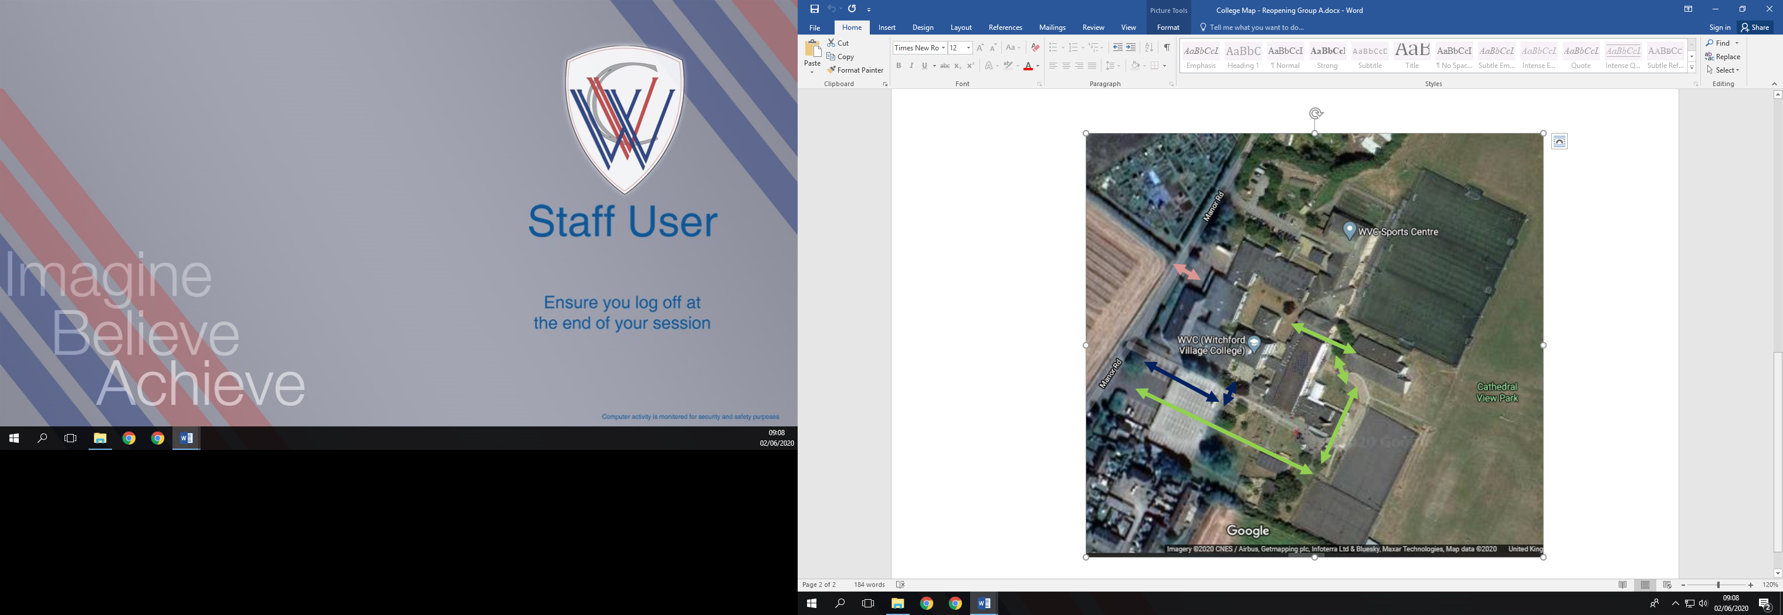

On meeting students from the bus, they will be directed towards their particular work area (Year 10 - green arrow, Key worker students – blue arrow, Year 6 students (Rackham staff led) – pink arrow)

All students will be allocated in to specific groups:

**Year 10 Rooms and spaces**

**Key worker rooms and spaces**

**Year 6 Rooms and Spaces**

All groups have their own toilets allocated to them and their own outside space if required. In the case of poor weather, breaks will be taken inside allocated rooms.

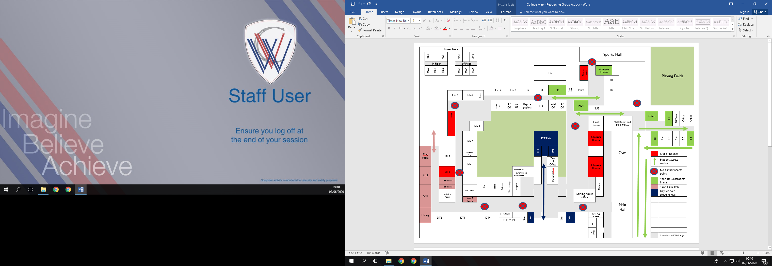

## Classes 1-3 English area

